**Abstract:**

The Black-Scholes-Merton model, which is used to price options, creates a theoretical connection between what's considered a "fair" price for an option and various factors that describe the option itself and the current state of the market. In simpler terms, it helps us figure out how much an option should cost based on specific details about the option and what's happening in the market at that time.

**Introduction:**

The Black-Scholes-Merton (BSM) model, introduced by Fischer Black, Myron Scholes, and Robert Merton in the early 1970s, revolutionized the field of finance by offering a groundbreaking framework for pricing European-style options. This mathematical model, based on key assumptions such as constant volatility, the absence of dividends, and efficient markets, utilizes partial differential equations to derive closed-form solutions for option prices.

**What is a Black-Scholes-Merton Model?**

The Black-Scholes-Merton (BSM) model is a pricing model for financial instruments. It is used for the valuation of stock options. The BSM model is used to determine the fair prices of stock options based on six variables: [**volatility**](https://corporatefinanceinstitute.com/resources/career-map/sell-side/capital-markets/volatility-vol/), **type**, **underlying stock price,** [**strike price**](https://corporatefinanceinstitute.com/resources/derivatives/strike-price/), **time**, and **risk-free rate**. It is based on the principle of hedging and focuses on eliminating risks associated with the volatility of underlying assets and stock options.

### **Black-Scholes-Merton Equation**

The Black-Scholes-Merton model can be described as a second order partial differential equation.

$$\frac{∂V}{∂t}+\frac{1}{2}σ^{2}S^{s}\frac{∂^{2}V}{∂S^{2}}+rS\frac{∂V}{∂S}-rV=0$$

The equation describes the price of stock options over time.

**Call Option Price (C):**

The Black-Scholes call option pricing formula is given by:

$$C=S_{o}N\left(d_{1}\right)-Xe^{-rT}N\left(d_{2}\right)$$

**Put Option Price (P):**

The Black-Scholes put option pricing formula is given by:

$$P=Xe^{-rT}N\left(-d_{2}\right)-S_{0}N\left(-d_{1}\right)$$

Where:

* C is the call option Price.
* P is the put option Price
* $S_{o}$ is the current price of the underlying asset.
* $X$ is the strike price of the option.
* $T$ is the time to expiration in years.
* r is the risk-free intrest rate.
* $N$ is the cumulative distribution function of the standard normal distribution.

$d_{1}=\frac{\ln\left(\frac{S_{0}}{X}\right)+\left(r+\frac{σ^{2}}{2}\right)T}{σ\sqrt{T}}$

$d_{2}=d_{1}-σ\sqrt{T}$

In these formulas, $N\left(d_{1}\right)$ and $N\left(d_{2}\right)$ represent the probabilities associated with the standard normal distribution. The call option price (C) is the price an investor pays for the right to buy the underlying asset at the strike price, while the put option price (P) is the price for the right to sell the underlying asset at the strike price. These prices are calculated based on the assumptions of the Black-Scholes Model, including constant volatility, risk-free interest rate, and no dividends.

**Key Characteristics:**

The Black-Scholes Model, used for pricing European-style options, has several key characteristics:

1. **European-Style Options**: The model is specifically designed for European-style options, which can only be exercised at expiration. This means that the right to buy or sell the underlying asset is only executed at the option's maturity date. This simplifies the calculations compared to American-style options, which can be exercised at any time before or at expiration.
2. **Volatility:** Volatility is a crucial input in the model, representing the standard deviation of the asset's returns. The model assumes constant volatility over the life of the option.
3. **Continuous Time:** The Black-Scholes Model uses continuous time in its calculations, assuming that the price of the underlying asset changes smoothly over time. This is a departure from discrete time models.
4. **Greeks:** The Black-Scholes Model introduced the concept of "Greeks," which are measures of how sensitive the option price is to changes in various factors. The main Greeks include Delta, Gamma, Theta, Vega, and Rho.
5. **Closed-Form Solution:** The model provides closed-form solutions for both call and put options, making it relatively easy to calculate the theoretical option prices.
6. **Widely Used:** Despite its assumptions and limitations, the Black-Scholes Model is widely used in finance for options pricing. It has had a significant impact on the field and serves as a foundation for more complex option pricing models.

**Assumptions:**

1. **Efficient Markets:** The model assumes that financial markets are efficient, meaning that prices reflect all available information, and there are no opportunities for risk-free profits through arbitrage.
2. **Constant Volatility:** The volatility of the underlying asset's returns is assumed to be constant over the life of the option. In reality, volatility can change over time, and this assumption may not always hold.
3. **Continuous Trading:** The model assumes continuous trading and allows for the continuous buying and selling of the underlying asset with no restrictions or transaction costs.
4. **No Dividends:** The original Black-Scholes Model assumes that the underlying asset does not pay any dividends during the life of the option. However, extensions of the model have been developed to account for dividend payments.
5. **Log-Normal Distribution:** The model assumes that the distribution of the underlying asset's returns follows a log-normal distribution. This assumption is based on the idea that asset prices evolve according to geometric Brownian motion.
6. **Risk-Free Interest Rate:** The model assumes a constant risk-free interest rate, representing the return on a risk-free investment. This rate is used to discount future cash flows to their present value.
7. **No Transaction Costs:** The Black-Scholes Model assumes that there are no transaction costs associated with buying or selling the underlying asset or the option itself.
8. **No Market Frictions:** The model assumes a frictionless market with no restrictions on short selling, borrowing, or lending.

**Applications:**

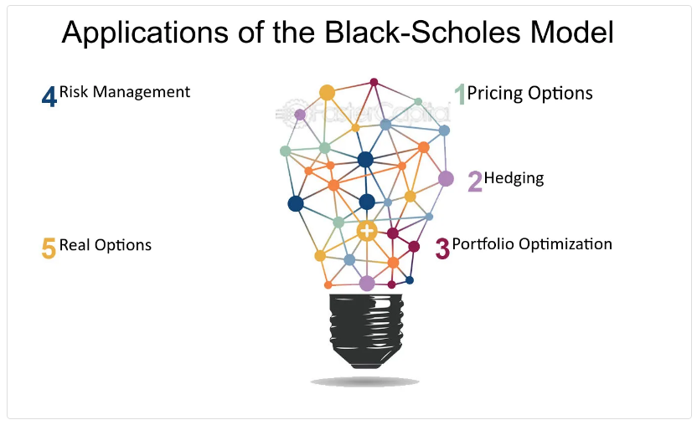 The Black-Scholes Model has found widespread applications in the field of finance, particularly in the pricing and risk management of financial derivatives, especially options. Here are some key applications of the Black-Scholes Model:

**Limitations:**

* The model can only be used to price the European option because it only considers the maturity date. The model is useless for American options as they can be practiced anytime before maturity.
* The model assumes that the volatility remains constant till the maturity date, but the volatility keeps fluctuating.
* The model also assumes that the risk-free interest rate remains constant throughout the option’s life, i.e., till the maturity date.
* The model assumes there is no transaction fee, which is not possible in the market.
* The model assumes that the price fluctuations are completely random, but research shows that fluctuations tend to keep going up in the intermediate terms and vice versa.

**Benefits:**

* Provides a Framework:
* Allows for Risk Management:
* Allows for Portfolio Optimization:
* Enhances Market Efficiency:
* Streamlines Pricing

**Derivation of Black Scholes Model:**

$\left(V\left(s,t\right)\right)→$ Option

P $→$ Portfolio

S $→$ Share price/ Stock price

$∆ →$ Change of share

$$P=V\left(s,t\right)-∆S$$

Taking differential on both sides

$dP=dV-∆dS$**……. $\left(1\right)$**

As,

We know that, **Geometric Brownian Motion**

𝑑𝑆=𝜇𝑆𝑑𝑡+𝜎𝑆𝑑𝑤 **……. $\left(2\right)$**

Growth rate drift voltality

**From Ito’s Lemma:**

$dV=\frac{∂V}{∂t}dt+\frac{∂V}{∂S}dS+\frac{1}{2}\frac{∂^{2}V}{∂S^{2}}{dS}^{2}$**……. $\left(3\right)$**

$$∴{dS}^{2}={\left(μSdt+σSdw\right)}^{2}$$

$$dS=μ^{2}S^{2}dt∙dt+2μσS^{2}dt∙dw+σ^{2}S^{2}dw∙dw$$

$$∴dt∙dt=0, dt∙dw=0, dw∙dw=dt$$

$dS=σ^{2}S^{2}dt$**Put in eq $\left(3\right)$**

$\left(3\right)⟹dV=\frac{∂V}{∂t}dt+\frac{∂V}{∂S}dS+\frac{1}{2}\frac{∂^{2}V}{∂S^{2}}σ^{2}S^{2}dt$**……. $\left(4\right)$**

**Using eq $\left(4\right)$ in eq $\left(1\right)$, we get**

$$\left(1\right)⟹ dP=\frac{∂V}{∂t}dt+\frac{∂V}{∂S}dS+\frac{1}{2}\frac{∂^{2}V}{∂S^{2}}σ^{2}S^{2}dt-∆dS$$

$$dP=\left(\frac{∂V}{∂t}+\frac{1}{2}\frac{∂^{2}V}{∂S^{2}}σ^{2}S^{2}\right)dt+\left(\frac{∂V}{∂S}-∆\right)dS$$

$∴∆=\left(\frac{∂V}{∂S}\right)$ (change in value of option)

$$dP=\left(\frac{∂V}{∂t}+\frac{1}{2}\frac{∂^{2}V}{∂S^{2}}σ^{2}S^{2}\right)dt+\left(\frac{∂V}{∂S}-\frac{∂V}{∂S}\right)dS$$

$dP=\left(\frac{∂V}{∂t}+\frac{1}{2}\frac{∂^{2}V}{∂S^{2}}σ^{2}S^{2}\right) dt$**……. $\left(5\right)$**

And,

$dP=r∙Pdt=\left(rV-rS\left(\frac{∂V}{∂S}\right)dt\right) dt$**……. $\left(6\right)$**

**Combining eq $\left(5\right)$& eq $\left(6\right)$**

$$\frac{∂V}{∂t}+\frac{1}{2}σ^{2}S^{2}\frac{∂^{2}V}{∂S^{2}}=rV-rS\frac{∂V}{∂S}$$

$$\frac{∂V}{∂t}+\frac{1}{2}σ^{2}S^{2}\frac{∂^{2}V}{∂S^{2}}-rV+rS\frac{∂V}{∂S}=0$$

This is known as the equation of Black Scholes Model.

**Problem Statement:**

Consider a financial scenario where the current stock price $\left(S_{0}\right)$ is

$100, the option strike price is $105, the risk-free intrest rate (r) is 15%,

voltality $\left(σ\right)$ is $30\%$ and the time of expiration $\left(T\right)$ is 6 months (0.5 years)

Utilize the Black-Scholes-Model to calculate the theoretical prices of an

European call option (C) and a European put option (P). Provide a

step-by-step calculation for both options using the given parameters.

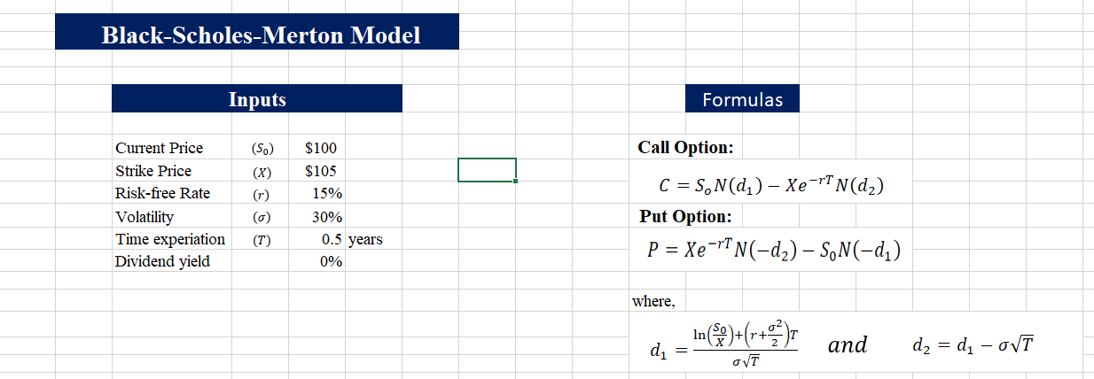

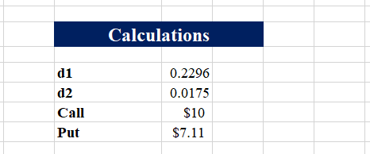

**Conclusion:**

In conclusion, the Black-Scholes-Merton model is like a math wizard for pricing options in the stock market. It's been super useful for investors to figure out how much an option might be worth and to manage risks when dealing with these financial contracts. However, it has its limits—like assuming that market conditions stay the same, which isn't always true. People are working on new models to improve on these limitations and make our understanding of option pricing even better. So, while the Black-Scholes model is a great starting point, there's always room for improvement in the world of finance math.